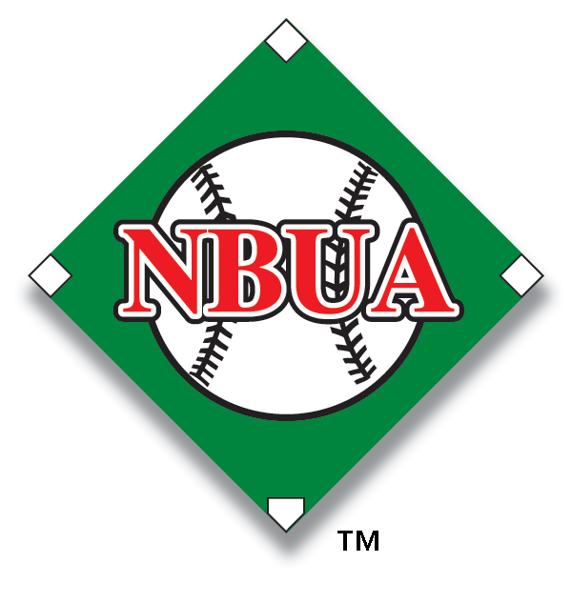
Expectations of "B" Tier Umpires
Basic 2-Man Mechanics
Knows & understands rotations
o First to third
o Home to third
Knows responsibilities of plate and base umpires
o Fair / Foul - who has the line
o Catch / No catch
o Out / Safe
o Knows when to go out on a fly ball
Umpire Communications
o Consistently vocalizes balls and strikes
o Consistently vocalizes safes and outs
o Consistently vocalizes catch and no catch (when necessary)
o Consistently vocalizes foul ball (when necessary)
o Consistently signals and vocalizes situations with partner
Strike Zone Quality
o Has a good knowledge of strike zone
o Is beginning to develop strike zone consistency
o Is beginning to develop consistency in timing
Tag Plays
o Knows responsibility of what to do on tag-up situations
o Knows responsibility when ball is hit in the air in "the cone"
Rules Knowledge
o Knows rules differences between high school and professional
o Knows infield fly rule
o Knows, can identify, and enforce balk rules
- Has a good understanding of both the Obstruction & Interference rules/mechanics
Uniform
o Presentable (Every game)
o Correct uniform
o Clean hat, shirt, and pants
o Pressed pants and shirt
o Shined shoes
Punctuality
o Is on time (arrives 45 minutes before game time)
o Is prepared to work either position
Attitude
o Knows what comments to ignore and which comments require a response
o Conducts himself / herself in a professional manner
o Is able to accept constructive criticism
Peer Evaluations
- Consistently enters all Peer Evaluation information into Arbiter
- Enters PE info within 24 hours of the completion of each game
- Signs & dates every Peer Evaluation
- Notes game site & level of play on every Peer Evaluation
Partner Evaluations
- Effectively & timely gives Partner Evaluations to (4) C Tier & (4) Apprentice Tier umpires (and as needed)

